: How to configure RDS:

To sign up for Amazon RDS

Go to http://aws.amazon.com/rds and click Sign Up for Amazon RDS.
Follow the on-screen instructions.
Once you've signed up for Amazon RDS, you'll be able to begin the process of creating your own DB Instance.

Creating a DB Security Group

To create a DB Security group for this example, you enter CIDR (Classless Inter-Domain Routing) notation to specify either a single IP address or a range of IP addresses that you will allow to connect to your DB Instance. Since these IP addresses will be allowed access, it is important that you grant access to the correct IP addresses.

To create a new DB Security Group

In the left column of the AWS Management Console, click DB Security Groups.
In the My DB Security Groups page, click the Create DB Security Group button.

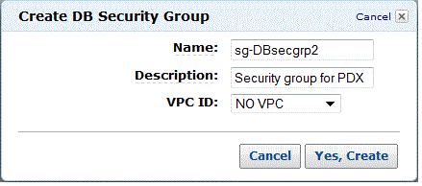

In the Create DB Security Group dialog box, type the name of the security group and a brief description. If you are using a Virtual Private Cloud (VPC), enter the ID of the VPC instance. Click Yes, Create to close the dialog box and show the My DB Security Groups page of the AWS Management Console.

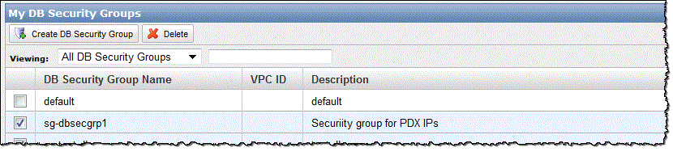

On the My DB Security Groups page, the DB Security Group you created is selected. On the Description tab at the bottom of the window, select CIDR/IP from theConnection Type drop-down list. Type your CIDR range into the CIDR text box, and click the Add button.

Note
The IP address you enter should be the public-facing address or range of addresses of the computers that will be accessing the DB Instance. If you are behind a firewall, the IP addresses could be a limited set of addresses that the firewall exposes. To help you determine your current IP address, the CIDR range for your current IP address appears on the page just below the CIDR text box. Due to how firewalls work, this value may not be the publically visible IP address you need to provide in the CIDR textbox. For information about the IP addresses you should include in the security group, consult with your network administrator.

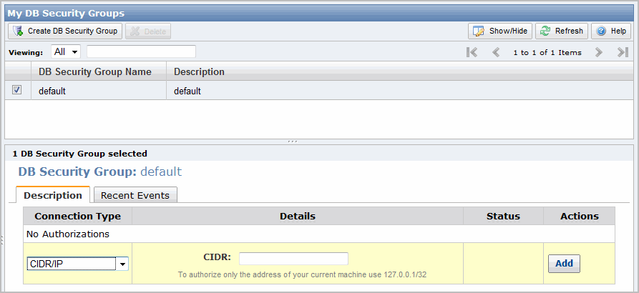

You will use the name of the DB Security Group in the next step when you launch your DB Instance. Click the following button.
Now that you have signed up for Amazon RDS and created a DB Security Group, you're ready to launch a DB Instance using the AWS Management Console.

Important

The DB Instance you're about to launch will be live (and not running in a sandbox). You will incur the standard Amazon RDS usage fees for the instance until you terminate it. The total charges will be minimal if you complete the exercise described here in one sitting and terminate your DB Instance when you are finished. For more information about Amazon RDS usage rates, go to the Amazon RDS product page.
The quickest way to create a new DB Instance is by using the AWS Console. Once you select the DB Engine you want to use, the process for creating the DB Instance is specific to the DB Engine.

To launch a DB Instance

Sign in to the AWS Management Console and open the Amazon RDS console at https://console.aws.amazon.com/rds/.
In the left column of the AWS Console, select the region in which you want to create the DB Instance. This should be the same region as the region in which you created your DB Security Group in the previous step.

Click Launch DB Instance to start the Launch DB Instance Wizard.

The wizard opens on the Engine Selection page.
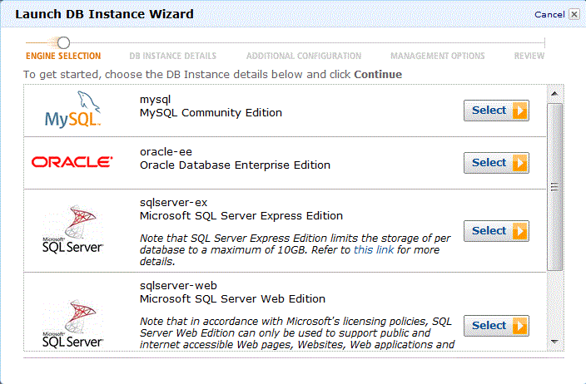

Click the Select button for the DB Engine that you want to install in the DB Instance you are launching.

Note

To use the suggested values in this tutorial for a SQL Server DB Engine, select Microsoft SQL Server Express Edition.
To continue, select the link that corresponds to the DB Engine you chose:
Launching a MySQL DB Instance
Launching an Oracle DB Instance
Launching a Microsoft SQL Server DB Instance
Launching a MySQL DB Instance

To launch a MySQL DB Instance

Once you have selected MySQL as your DB Engine, the wizard displays the DB Instance Details page for MySQL. The most important parameters you set here are for the DB Instance Class in the DB Instance Class drop-down list and the Allocated Storage text box. The DB Instance class defines the CPU and memory capacity of your DB Instance, which can impact processing speed and responsiveness. The allocated storage value determines how much storage is allocated for this DB Instance. Note that these two values are used to calculate the cost of your DB Instance.
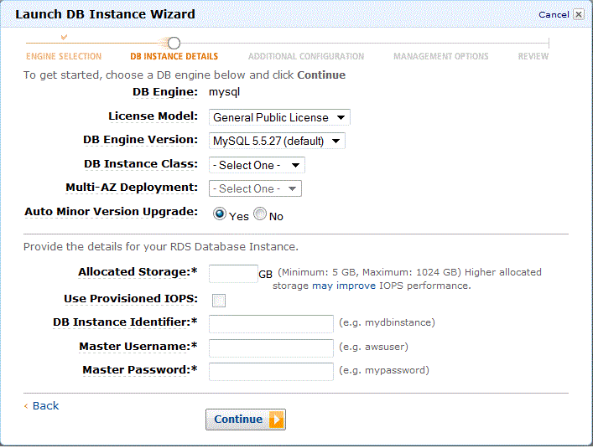

On the Additional Configuration page, you provide additional information that RDS needs to launch the DB Instance for MySQL. Specify your DB Instance information as shown in the following table, then click Continue.

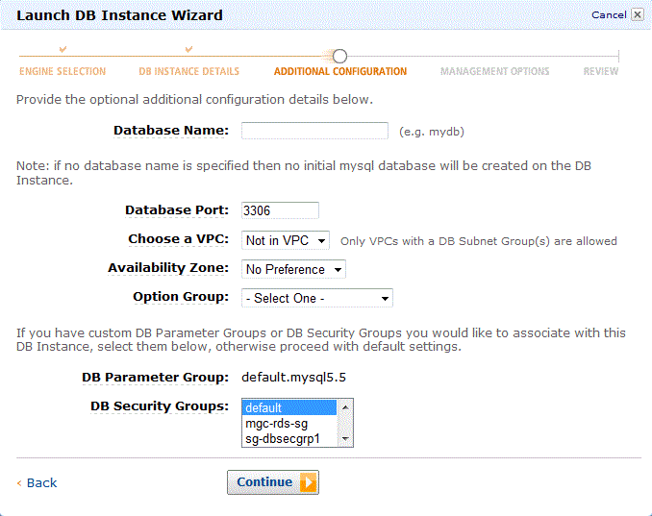

On the Management Options page, you can specify backup and maintenance options for your DB Instance. For this example, accept the default values, and then clickContinue. Note that setting the Backup Retention Period to zero disables automatic backups.

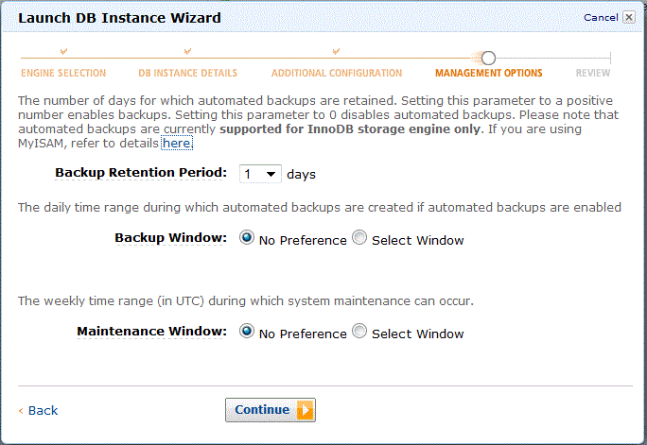

In addition, Federated Storage Engine is currently not supported by Amazon RDS for MySQL.

Note

The Point-In-Time-Restore and Snapshot Restore features of Amazon RDS for MySQL require a crash recoverable storage engine and are supported for the InnoDB storage engine only. While MySQL supports multiple storage engines with varying capabilities, not all of them are optimized for crash recovery and data durability. For example, the MyISAM storage engine does not support reliable crash recovery and may result in lost or corrupt data when MySQL is restarted after a crash, preventing Point-In-Time-Restore or Snapshot restore from working as intended.
If you would like to convert existing MyISAM tables to InnoDB tables, you can use the alter table command (e.g., alter table TABLE_NAME engine=innodb;). Note that MyISAM and InnoDB have different strengths and weaknesses, so you should fully evaluate the impact of making this switch on your applications before doing so.
On the Review page, review the options for your DB Instance:
If you need to correct any options, click Back to return to previous pages and make corrections. You can also modify a DB Instance from the AWS Console after you have launched a DB Instance.

If all your options are entered correctly, click the Launch DB Instance button to launch your new DB Instance.
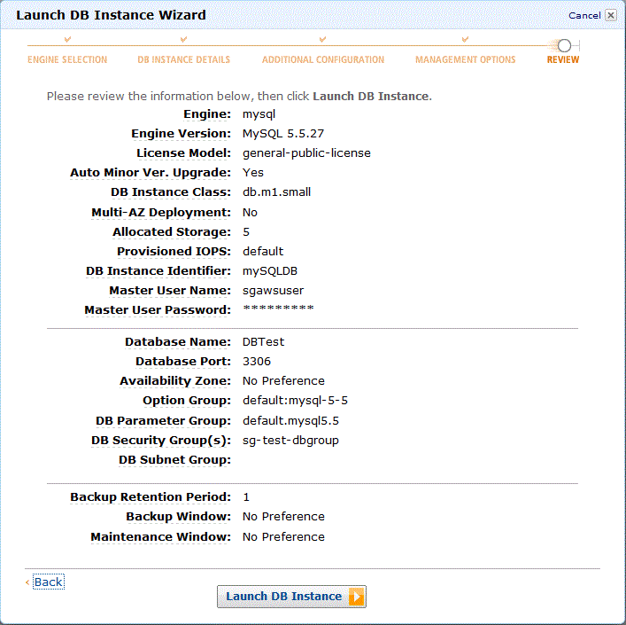

On the dialog box that indicates that your DB Instance is being created, click the Close button.

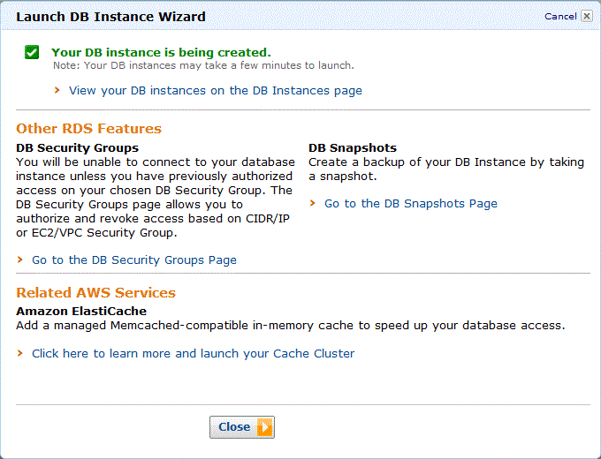

On the AWS Management Console, the new DB Instance appears in the list of DB Instances. The DB Instance will have a status of creating until the DB Instance is created and ready for use. Depending on the DB Instance class and store allocated, it could take several minutes for the new instance to be created.

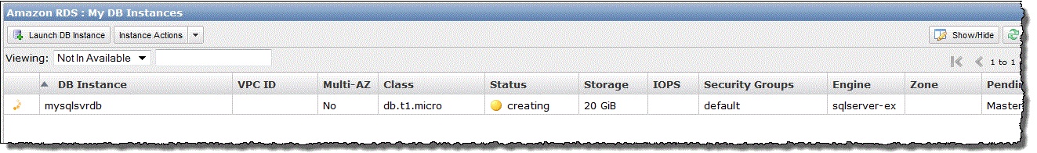

Once your DB instance changes to the available state, you can connect to it.

